`

Student Name
Teacher | GSL | MDI | HAL | SMH

CHEMISTRY
Unit 3, SAC 2
Test on concepts from Chapters 7-8 of Heinemann Chemistry 2
Rate and extent of chemical reactions

1st June 2020, Period 4
Reading time: 5 minutes
Writing time: 60 minutes

Structure of Report
Task and Section | Number of questions | Number of questions to be answered | Number of marks
Section A Multiple Choice Questions | 10 | 10 | 10
Section B Short Answer Questions | 6 | 6 | 36
 |  |  | Total 46

- Students are permitted to bring into the assessment room: pens, pencils, highlighters, erasers, sharpeners, rulers and one scientific calculator.
- Students are not permitted to bring into the examination room: blank sheets of paper and/or white out liquid/tape.
Materials supplied
- This question and answer book of 12 pages.
- A data book
Instructions
- Write your name in the space provided above on this page.
- All responses must be written in English.
- Working out must be shown for all calculations
- Do NOT write on the data book
At the end of the assessment session
- Wait silently for the supervisor to collect your booklet and data book.
Students are NOT permitted to bring mobile phones and/or any other unauthorised electronic devices into the examination room.
Students must not disclose the contents of the task; to do so will be a breach of VCE guidelines and will be dealt with according to VCAA regulations.

SECTION A: Test Multiple-Choice Questions

Instructions for Section A
Answer all questions in pencil on the answer sheet provided for multiple choice questions.
Choose the response that is correct or that best answers the question.
A correct answer scores 1, an incorrect answer scores 0.
Marks will not be deducted for incorrect answers.
No marks will be given if more than one answer is completed for any question.

Question 1
Which statement is correct as the temperature for a sample of a gas, X, increases?

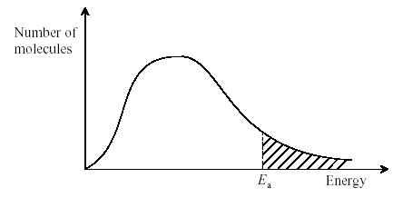

A. The area under the curve to the left of Ea decreases.
B. The total area under the curve increases.
C. The activation energy decreases.
D. More molecules have the mean energy.

Question 2
Reaction rates generally increase with an increase in temperature. Four suggested reasons are:

- Molecules collide more frequently at higher temperatures.
- As the temperature of a reaction increases, the activation energy for the reaction decreases.
- The concentration of reactants will be greater at a higher temperature.
- The fraction of high energy molecules is greater at higher temperatures.

The correct statements are:
- II and IV only
- I and IV only
C. I, II and IV only
D. I, III, and IV only

Question 3
It is generally believed that catalysts increase reaction rates by:

A. removing the activation energy barrier and lowering the change in enthalpy, ∆H.
B. providing an alternate activation energy barrier that is lower than the original activation energy barrier.
C. lowering the activation energy barrier and increasing the change in enthalpy, ∆H.
D. giving the reacting particles more energy, thus there will be more successful collisions

Question 4
If the reaction quotient Q has a smaller value than the related equilibrium constant, K

A. the reaction is at equilibrium.
B. the reaction is not at equilibrium, and will make more products at the expense of reactants.
C. the reaction is not at equilibrium, and will make more reactants at the expense of products.
D. the value of K will decrease until it is equal to Q

Question 5
If 0.10 mol of gas A and 0.10 mol of gas B are initially added to a 1L container, which of the following must be true once the mixture achieves equilibrium?

A + 2B $⇌$ 2C K_{c} = 320 M⁻¹
- [A] = [B]
- [B] = 2[C]
- [A] < [B]
- [A] > [B]

Question 6
The equilibrium constant for the formation of sulphur trioxide from sulphur dioxide and oxygen gas is 4.3 M⁻¹ according to the reaction:

2SO₂(g) + O₂ (g) $⇌$ 2SO₃ (g) K_{c} = 4.3 M⁻¹

What is the value of the equilibrium constant for the reverse of this reaction?

- –4.3
- –0.23
- 0.23
- 0.43

Question 7
Nitrogen dioxide, NO₂ (a brown gas) and dinitrogen tetroxide, N₂O₄ (a colourless gas) are in equilibrium according to the equation
2NO₂(g) $⇌$ N₂O₄(g)

An equilibrium mixture of the two gases at room temperature is light brown but at higher temperatures the colour becomes a much deeper brown. What conclusion can be drawn from this observation?

A. The reverse reaction in the equation is endothermic.
B. The forward reaction in the equation is endothermic.
C. The brown colour is due to the strong nitrogen–oxygen bonds in NO₂.
D. The equilibrium concentration of N₂O₄ is not dependent on temperature.

Question 8
Three gases X, Y and Z were mixed in a closed container and allowed to reach equilibrium. A change was imposed at time T and the equilibrium was re-established. The concentration of each gas is plotted against time.

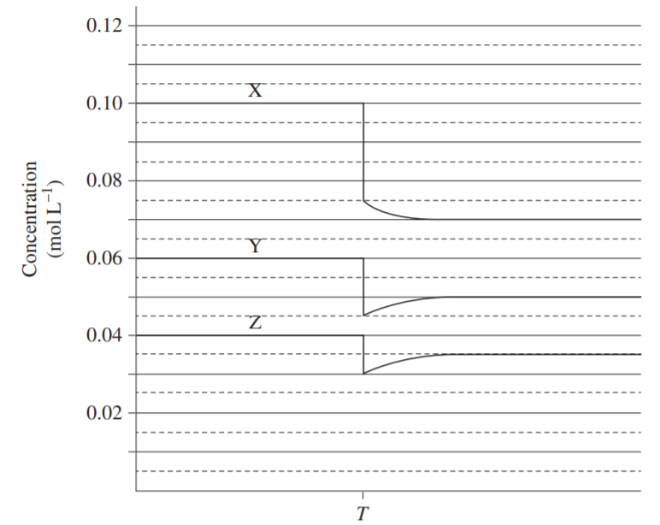

Which reaction does the graph represent?
A. X(g) + Y(g) $⇌$ 2Z(g)
B. 2X(g) $⇌$ Y(g) + Z(g)
C. 2X(g) $⇌$ Y(g) + 3Z(g)
D. X(g) $⇌$ Y(g) + Z(g)

Question 9
Consider the following reaction:

N₂ (g) + O₂(g) $⇌$ 2NO(g) ∆H = +176 kJ mol⁻¹

An increase in temperature would:

- Shift the equilibrium in favour of the reverse reaction and increase the value of K.
- Shift the equilibrium in favour of the forward reaction and decrease the value of K.
- Shift the equilibrium in favour of the forward reaction and increase the value of K.
- Cause no change to the system.

Question 10

Ammonia, ( NH₃ ) is produced during the Haber Process and it is in equilibrium with nitrogen,( N₂ ) and hydrogen gas, ( H₂ ).

N₂ (g) + 3H₂(g) $⇌$ 2NH₃(g) ∆H = -91 kJ mol⁻¹

Which change would improve the yield of NH₃(g) at equilibrium?

A. increase the temperature
B. use a catalyst
C. decrease the volume
D. add large amounts of argon gas

End of Section A
Section A: Multiple Choice Answer Sheet
This answer sheet must not be detached from this booklet.
INSTRUCTIONS FOR MULTIPLE CHOICE ANSWER SHEET
Use a PENCIL for ALL entries. For each question, shade the box which indicates your answer.
Marks will NOT be deducted for incorrect answers.
NO MARK will be given if more than one answer is completed for any question.
If you make a mistake, ERASE the incorrect answer - DO NOT cross it out.

1 |  | A |  | B |  | C |  | D
2 |  | A |  | B |  | C |  | D
3 |  | A |  | B |  | C |  | D
4 |  | A |  | B |  | C |  | D
5 |  | A |  | B |  | C |  | D
6 |  | A |  | B |  | C |  | D
7 |  | A |  | B |  | C |  | D
8 |  | A |  | B |  | C |  | D
9 |  | A |  | B |  | C |  | D
10 |  | A |  | B |  | C |  | D

SECTION B Test Short Answer Questions

Instructions for Section B
Answer all questions in the spaces provided. Write using black or blue pen.
To obtain full marks for your responses you should:
- Give simplified answers with an appropriate number of significant figures to all numerical questions; un-simplified answers will not be given full marks.
- Show all working in your answers to numerical questions. No marks will be given for an incorrect answer unless it is accompanied by details of the working.
- Make sure chemical equations are balanced and that the formulas for individual substances include an indication of state; for example, H₂(g); NaCl(s)

Question 1 (4 marks)
For the following reaction, write how each of the changes will affect the indicated quantity, assuming a container of fixed size.
Write “increase”, “decrease”, or “no change”.
For a chemical added, write how it would respond AFTER the initial spike due to the addition.
H₂(g) + Br₂(g) $⇌$ 2HBr(g) ΔH = -103.7kJ mol⁻¹

Change | [H₂] | [Br₂] | [HBr] | K value
H₂ added
HBr added
The temperature is increased
Pressure is increased

Question 2 (10 marks)
Hydrogen peroxide is a mild antiseptic which can decompose according to the equation:
catalyst
2H₂O₂ (aq) → 2H₂O (l) + O₂ (g)

- Referring to the Collision Theory, explain the role of the catalyst in the decomposition of hydrogen peroxide.
(2 marks)

An experiment was set up to investigate the decomposition of 1.0L of hydrogen peroxide solution at two different temperatures, one at SLC and the other at a higher temperature using the set up shown below:

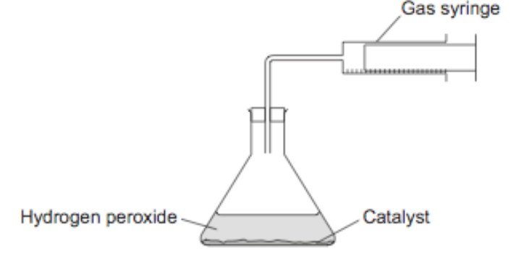

A graph was drawn to represent the information at these two temperatures.
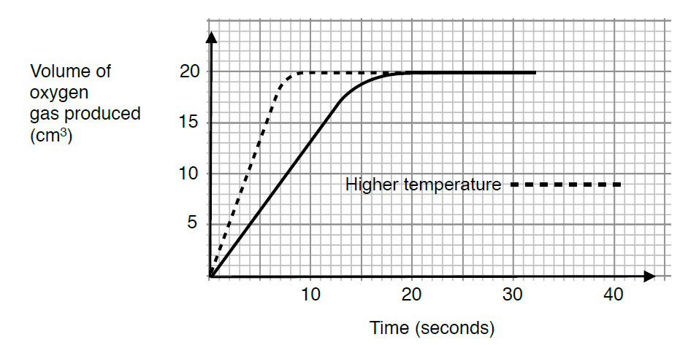
(mL)

- Use the Collision Theory to explain the shape of the graph for the higher temperature.
(3 marks)

- Explain why both of the graphs eventually level off and become horizontal to the x axis.
(1 mark)

d. i. Calculate the amount, in mol of the oxygen gas produced by the decomposition of the hydrogen peroxide, H₂O₂ at the lower temperature. (1 mark)

- Calculate the concentration of the hydrogen peroxide in % m/v. (3 marks)

Question 3 (3 marks)

Explain, in terms of particles, why the rate of non-equilibrium reactions decrease over time.

Question 4 (6 marks)

An industrial plant makes ammonia from nitrogen gas and hydrogen gas. The reaction is exothermic. The graph, not drawn to scale, shows the adjustments made to increase the production of ammonia.

N₂(g) + 3H₂(g) $⇌$ 2NH₃(g) ∆H = –92 kJ mol^{–1}

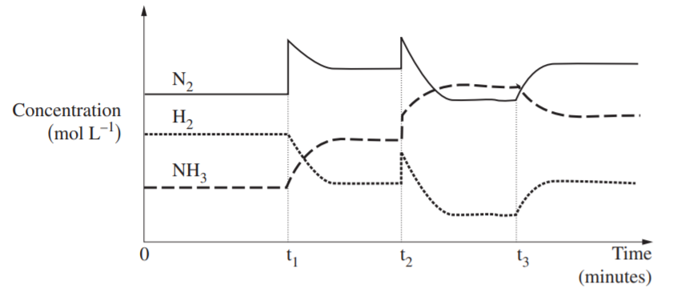

- Complete the table to identify what possible changes occurred at times t₁, t₂ and t₃. (3 marks)

Time | Cause for change
t₁
t₂
t₃

- Use Le Chatelier’s Principle to explain the cause for the change in the graph at one of the times.(t₁ or t₂)

State the section of the graph, t₁ or t₂ you will use to explain the change in your answer.
(2 marks)
Section of graph:

Explanation:

- Would the temperature of the mixture increase, decrease or remain the same between t₂ and t₃? Explain your reasoning. (1 mark)

Question 5 (9 marks)

Phosphoryl chloride, (POCl₃) is manufactured industrially on a large scale from phosphorus trichloride, (PCl₃ ) and oxygen according to the reaction:

2PCl₃(g) + O₂ (g) $⇌$ 2POCl₃ (g) ∆H = −560 kJ mol⁻¹

The change in concentration of phosphoryl chloride with time when only PCl₃ gas and O₂ gas are present initially in a 1.0 L sealed container at 400⁰C is shown below:

POCl₃
(mol L⁻¹)

0.14

0.12
Time
0.02
0.04
0.06
0.088
0.10

A

B

- Write the equilibrium expression for the reaction, include units. (2 marks)

- At 400⁰C the reaction quotient for the reaction at point A is 1.2 x 10³ M⁻¹ and the concentration of PCl₃ is 0.030 mol L⁻¹. Calculate the concentration of O₂ at point A.
(2 marks)

- i. Use Le Chatelier’s Principle to explain whether the temperature was increased or decreased at point B. (2 marks)

- Use the equilibrium expression from part a. to explain the effect that the temperature would have on the equilibrium constant, K_{c} at Point B. (2 marks)

- Explain how the system will be affected by the addition of a catalyst at Point B. (1 mark)

Question 6 (4 marks)
4.00 mol of HI(g) was added to an evacuated 2.00L reaction vessel and allowed to reach equilibrium at a constant temperature, according to the equation:
2HI (g) $⇌$ H₂(g) + I₂ (g)

At equilibrium, 0.25 mol of I₂ formed.
Calculate the equilibrium constant for the reaction.

END of TASK

